FOR GRANVILLE RESIDENTS

Reflective Address Marker Fundraiser
The Granville Fire Department Association is holding a fund raiser that will benefit both homeowners and the Granville Fire Department.
Federal, state, and local governments have invested millions and millions of dollars into technologically advanced E-911 systems over the past 15-20 years. Even today, the hot topic is wireless E-911 concerning cell phones dialing 911. However, with all of this technology, we've left out one small, basic tool. People don't mark their addresses sufficiently for emergency personnel to find them.
We are offering signs for sale that have a green reflective background with white reflective numbers. The signs are constructed on 100% aluminum and measure 18 inches long by 6 inches wide with rounded corners. Holes are pre-drilled in two arrangements so that you can display your sign horizontally or vertically at the end of your driveway where it will be visible in case of an emergency. The cost is $20.00 and is payable when you pick up your sign. A GFD member will contact you when your sign is available to arrange a pick up time and location. We encourage all homeowners to participate in this program. Installation is available for senior citizens upon request.
Below are some sample photographs of the signs:
Horizontal Mounting:  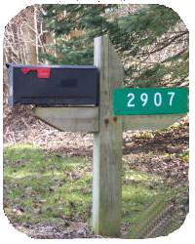 | Vertical Mounting:  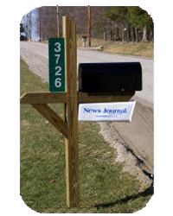 | It's Reflective!  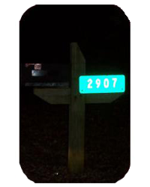
Mounting Note:
The signs in these sample photos are shown mounted on mailboxes. The GFD does not recommend mounting your sign on your mailbox. Mailboxes are not always located in a manner that identifies the specific residence. Your sign will better identify your residence if it is mounted right at the end of your drive way. Also, signs mounted on mailboxes tend to get buried in snow banks by the end of a long winter.
NOTE: Signs do not include mounting materials such as screws / brackets.

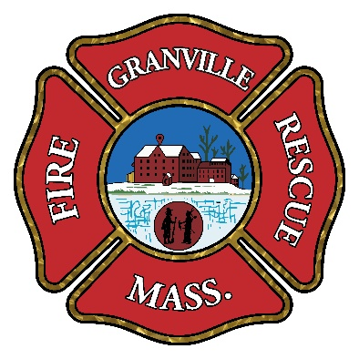

REFLECTIVE ADDRESS MARKER
ORDER FORM
Please complete the following information

Name: ________________________________________
Address: _______________________________________
City, State, Zip: Granville MA 01034
Phone Number: (____)____________________________
COST: $20.00

ADDRESS NUMBER REQUESTED

NOTE: If your address has fewer than 5 digits, please X those boxes not used.

MOUNTING PREFERENCE
Select option:
V
E
R
T
I
C
A
L
Horizontal:
Mail to:
Granville Fire Department
P.O. Box 247
Granville, MA 01034

Vertical:
HORIZONTAL

